**The Major Parts**

**Android Studio**

If we look at the major parts of the Android developer tools and resources, we can start with the IDE, or integrated development environment, Android Studio. You can think of Android Studio as a program, but it really is more than that. It's a collection of software that works together to help you program, test, distribute, and collaborate on how you build your Android apps. When you install Android Studio, there is the tool itself. Android Studio allows you to visually build the layout of your app and write the code that defines how your app works. There is also the Android emulator and the device deployment tool that can push a device to physical hardware.

Android Studio allows developers to do the following. You can visually layout and design the interface of your app directly in Android Studio. Using the design tools, you can select things like buttons, textboxes, and other controls, and add them to the screen, and customize how they look, and how your code will work with them. You'll create all the code for your app in the Android Studio tool using the code features of the program. In addition to being a place to write your code, Android Studio has a lot of intelligence to the Java programming language and the components of Android, so it can help guide you and provide tips as you code and work more reliably.

When your code is done, you need to convert it from the programming language that you can understand to the native language that Android can understand. If there are any problems with your code, the compiler can find these, and give you messages that you can help you track down the errors or bugs and fix them. When you create a build of your app, you want to run it and test it to make sure that it works correctly. Even if your code compiles, there could still be a problem with your app. For instance, maybe you have a math formula coded incorrectly. In that case, you will only really know if the app has a problem if you run it.

You have two ways to run the app. You can simply run the app and it will install on your physically connected hardware or in the emulator. Then you can run the app and try it out and see if it works. You can also run it in a mode called debug mode. This is a way to integrate the running of your app with Android Studio, so you can interactively walk through the code of your app while the app is running. You can track all kinds of information including performance and pause on certain events. This is called debugging and it is done entirely within Android Studio. While you might be learning to build Android apps alone, at some point, you may work with multiple people on a single project.

Or you may be an independent developer that will build out a single app or multiple apps over the course of months or years, and you might want a way to archive earlier versions of code. Android Studio works with software called code repositories that allows multiple people to collaborate on a project and for code to be archived and saved as versions throughout the development of it over time. When you're ready to send your app to Google to list in Google Play, Android Studio will build the package that you will upload to Google for them to review and then list in the store. This includes defining the version number of your app, the description, icons, and other materials that will customize the look of your app.

Android Studio does a lot of things for you as a developer and the things I have mentioned here are only the most basic. There is a lot more that Android Studio can do for you, as you become more experienced as an app developer in the future.

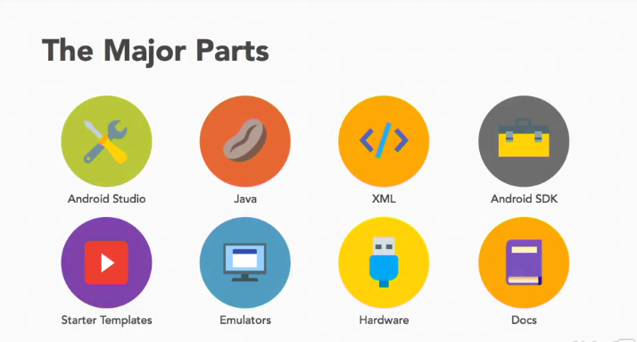

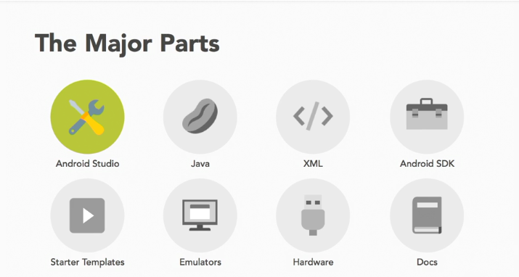

Android Studio:



